Knowledge Sharing Toolkit: Template
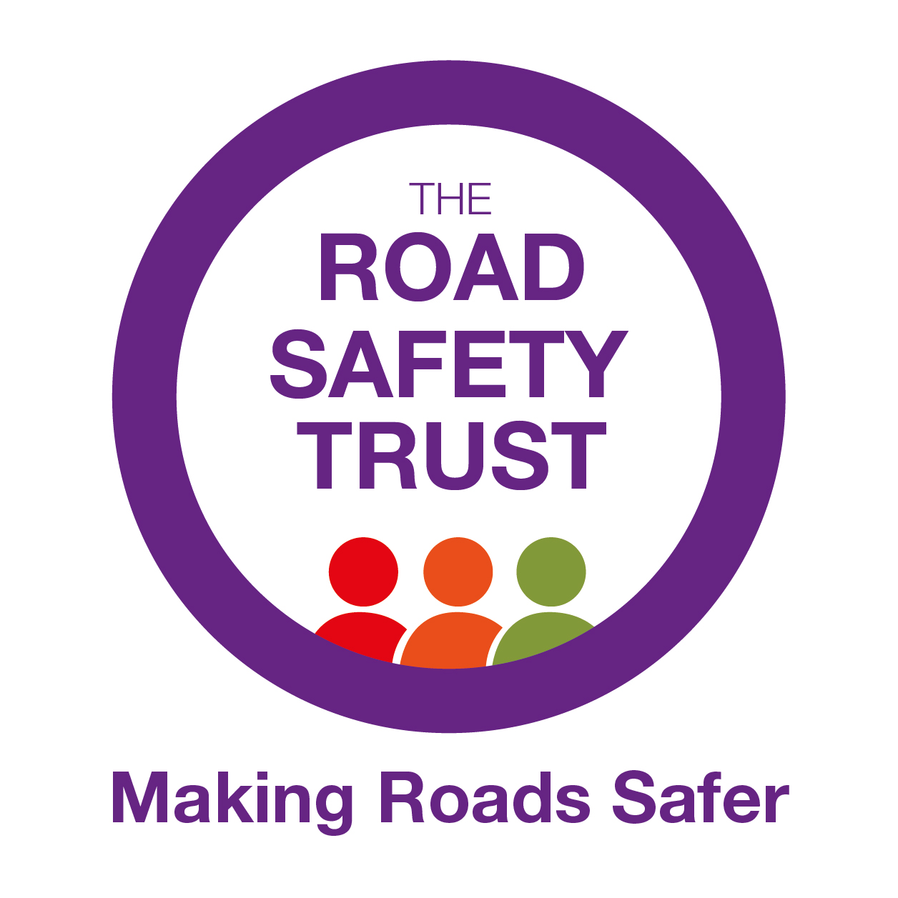
We would like you to complete the below table.
Once complete, this template can be used to focus your communications work on the areas that will deliver most impact.
The Road Safety Trust (RST) is here to support you, we are happy to work with you to complete the template or provide feedback and support. Please refer to the “How Can We Help?” section for additional resources provided by RST. These are also available on our website.

PROJECT DETAILS
Date:
Project Title:
Organisation:
Knowledge Sharing Lead:
PROJECT AIMS
COMMUNICATION AIMS

KNOWLEDGE SHARING AND EXCHANGE PLAN
Communication Activity | Audience | Resources | Timing | Evaluation

LONG TERM PLAN
Communication Activity | Audience | Resources | Timing | Evaluation

